**A Technical Report on**

**INTERNET OF THINGS (IoT): A SCOPE FOR THE DEVELOPMENT OF SMART HOMES AND BEYOND: A REVIEW**

**Submitted for partial fulfilment of award of**

**BACHELOR OF TECHNOLOGY**

**IN**

**INFORMATION TECHNOLOGY**

***by***

1. **ARYAN SRIVASTAV (Roll no. – 2005250130015)**
2. **PRERNA PANDEY (Roll no. – 2005250130040)**
3. **ANURAG YADAV (Roll no. – 2005250130013)**

**Under the Supervision of**

**MR. ABHISHEK SHAHI**

**(*Assistant Professor*)**



**BUDDHA INSTITUTE OF TECHNOLOGY**

**Affiliated to**

**DR. APJ ABDUL KALAM TECHNICAL UNIVERSITY, LUCKNOW**

**INDIA**

**JANUARY, 2023**

**Candidate’s Declaration**

I declare that this written submission represents my work and ideas in my own words and where other’s ideas or words have been included, I have adequately cited and referenced the original sources. I also declare that I have adhered to all principles of academic honesty and integrity and have not misrepresented or fabricated or falsified any idea/data/fact/source in my submission. I understand that any violation of the above will be cause for disciplinary action by the University and also evoke penal action from the sources which have thus not been properly cited or from whom proper permission has not been taken when needed.

ARYAN SRIVASTAV (Roll no. – 2005250130015)

PRERNA PANDEY (Roll no. – 2005250130040)

ANURAG YADAV (Roll no. – 2005250130013)

Department of Information Technology

Date: ___________

***Certificate***

This is to certify that **Mr. Aryan Srivastav**, **Ms. Prerna Pandey** and **Mr. Anurag Yadav** have carried out the research work presented in this dissertation entitled “**Internet of Things (IoT): A Scope for the development of Smart Homes and beyond: a review**” for the award of Bachelor of Technology from Buddha Institute of Technology, Gorakhpur under my supervision. The dissertation embodies result of original work and studies carried out by Student himself and the contents of the dissertation do not form the basis for the award of any other degree to the candidate or to anybody else.

Date: ___________

**(Mr. Manish Gupta)** (**Mr. Abhishek Shahi) Head of Department** **Assistant Professor**

**ABSTRACT**

IoT-based Home Automation System is a project that attempts to give consumers an automated way to control the equipment in their homes using a web application from anywhere on the planet. The project is planned and implemented using C++ language using the Arduino IDE.

With home automation, you may access and manage your house's appliances from any location in the globe using a mobile device. Homes with practically everything connected to a remotely controllable network, including lighting, appliances, electrical outlets, heating and cooling systems, are more appropriately referred to as home automation. This also includes automated doors, gas detection systems, fire alarms, and many more sensors from the perspective of home security.

Home Automation gives you access to control devices in your home from a mobile device anywhere in the world. Home Automation more accurately describes homes in which nearly everything – lights, appliances, electrical outlets, heating and cooling systems – are hooked up to a remotely controllable network. From a home security perspective, this also includes fire alarm system, gas detection system, automated doors, and many more sensors.

This report presents the design and implementation of an IoT-based home automation system using the ESP8266 microcontroller, sensors, and some home appliances. The system allows for remote control and monitoring of home appliances through a mobile application or web interface. The system can provide energy savings, improved safety, increased comfort, and increased convenience. However, it also poses security concerns that need to be addressed through appropriate security measures. The results of the system were analyzed against the goals and objectives set for the system, and areas for improvement and optimization were identified. Future research opportunities on IoT-based home automation systems include developing new and more secure methods, optimizing energy consumption, and improving the user experience.

**ACKNOWLEDGEMENTS**

“Achievements are of no means without the sense of gratefulness and recognition of this is the beginning of wisdom”

I think it is matter of pleasure to glance back and recall the way one travels, the days of hard and perseverance. At the end of my thesis, it is a pleasant task to express my thanks to all those who contributed in many ways to the success of this study and made it an unforgettable experience for me.

I consider to be extremely fortunate for the golden opportunity, to work under the guidance of experienced, my research guide **Mr. Abhishek Shahi**, Assistant Professor, and also, we humbly pay great regard to our Head of Department **Mr. Manish Gupta**, Department of Information Technology, Buddha Institute of Technology, GIDA, Gorakhpur, for his constant guidance, keen interest, constructive and adroit criticism and painstaking effort for scrutinizing the manuscript and continuous encouragement during the entire course of investigation I have no words to express my gratitude towards him.

Finally, I express my sense of gratitude towards all unknown who helped me directly and indirectly for completion of my research work. I also thank Almighty to bless me or everything.

**ARYAN SRIVASTAV (Roll no. – 2005250130015)**

**PRERNA PANDEY (Roll no. – 2005250130040)**

**ANURAG YADAV (Roll no. – 2005250130013)**

**LIST OF FIGURES**

**Fig. 2.1:** Description of the most notable events in IoT in year 2021…......................16

**Fig. 3.1:** Flowchart of the whole process during complete operation………………..20

**Fig. 4.1:** Microcontroller connected to all sensors, servo motor and buzzer………...24

**Fig. 4.2:** Another microcontroller connected to LEDs (using relay module)………..24

**Fig. 5.1:** Demonstration of switching of LEDs – OFF state…………………………25

**Fig. 5.2:** Demonstration of switching of LEDs – ON state…..………………………25

**Fig. 5.3:** Firing near the flame sensor to activate the sensor…………………………26

**Fig. 5.4:** Receiving notification of fire detection on Blynk app……………………..26

**Fig. 5.5:** Demonstration of infrared sensor – Inactive state………………………….26

**Fig. 5.6:** Activating the infrared sensor by putting an object nearby………………...26

**TABLE OF CONTENTS**

**CANDIDATE’S DECLARATION……………………………………………...2**

**CERTIFICATE……………………………………………………………….….3**

**ABSTRACT……………………………………………………………………....4**

**ACKNOWLEDGEMENTS……………………………………………………...5**

**LIST OF FIGURES……………………………………………………………...6**

**LIST OF TABLES…………………………………………………………...7 – 8**

**I. INTRODUCTION……………………………………………………….........9 - 12**

1.1 Introduction to IoT………………………………………………..9 - 10

1.2 Explanation of the concept…………………………………………...10

1.3 Applications of the technology………………………………………11

1.4 Aim of the Project…………………………………………………....12

**II. LITERATURE REVIEW………………………………………………….13 - 16**

2.1 Overview of existing technology…………………………………….14

2.2 Analysis of advantages and disadvantages……………………...14 – 15

2.3 Discussion on recent advancements…………………………….15 – 16

**III. TECHNICAL DETAILS………………………………………………….17 - 20**

3.1 Description of the components used……………………………..17 – 18

3.2 Explanation of how the system works……………………….…...18 – 19

3.3 Discussion on the programming languages………………………19 – 20

**IV. SYSTEM DESIGN AND IMPLEMENTAION………………………….21 - 24**

4.1 Experimental procedures…………………………………………..….22

4.2 Description of the overall architecture ………………………..………23

4.3 Circuit diagram………………………………………………………..24

**V. RESULT AND ANALYSIS………………………………………………...25 - 29**

5.1 Explanation of the result……………………………...………………25

5.2 Discussion of benefits achieved by the system………………….26 – 27

5.3 Analysis of any security concern…………………………….…..27 – 28

5.4 Points for the resolution of security concerns.......................................29

**VI. SUMMARY AND CONCLUSION………….……………………………30 - 33**

6.1 Summary……………………………………………………………...30

6.2 Conclusion.....................................................................................30 – 31

6.3 Scope for future research…………………………….…………..31 – 32

6.4 References…………………………………………….…………32 – 33

**INTRODUCTION**

IoT-based Home Automation System is a project that aims to provide users with a web application that allows them to automatically control the equipment in their homes from anywhere on the planet. The Arduino IDE is used to plan and carry out the project in C++.

With home automation, you can use a mobile device to access and control the appliances in your home from anywhere in the world. Home automation is a more fitting term for houses where almost everything is connected to a remotely programmable network, including lighting, appliances, and electrical outlets, heating and cooling systems. From the standpoint of house security, this also includes automatic doors, gas detection systems, fire alarms, and many more sensors.

With this system, you may access and manage your house's appliances from any location in the globe using a mobile device. Homes with practically everything connected to a remotely controllable network, including lighting, appliances, electrical outlets, heating and cooling systems, are more appropriately referred to as home automation. This also includes automated doors, gas detection systems, fire alarms, and many more sensors from the perspective of home security.

**1.1 Introduction to IoT:**

The Internet of Things (IoT) refers to the interconnectedness of physical devices, vehicles, buildings, and other items embedded with sensors, software, and network connectivity that enable these objects to collect and exchange data. The IoT allows for the seamless exchange of data between devices and systems, enabling automation, remote control, and the ability to gather and analyze large amounts of data. This allows for greater efficiency, cost savings, and new opportunities for innovation across a wide range of industries and applications.

IoT devices can include everything from smartphones and smart home appliances to industrial equipment and transportation systems. These devices are connected to the internet and can communicate with each other, allowing for automation and the ability to remotely control and monitor them. IoT technology is also used in areas such as healthcare, agriculture, transportation, and manufacturing to improve efficiency, safety, and decision-making.

The IoT is made possible by advances in technology such as miniaturization, wireless communication, and cloud computing. These advancements have led to the development of inexpensive sensors, powerful processors, and high-speed connectivity. This allows for the creation of connected devices that can be easily integrated into existing systems, making the IoT a rapidly growing and evolving technology.

**1.2 Explanation of the concept:**

The use of IoT technology in home automation allows for remote control and monitoring of the devices, as well as automation of tasks based on pre-set conditions or schedules. This can provide convenience and energy savings, as well as increased security through monitoring and alert systems.

In this specific project, the ESP8266 microcontroller serves as the central hub or controller. It is a low-cost, low-power microcontroller with built-in Wi-Fi capabilities. It can be programmed to communicate with various sensors and devices in the home, such as temperature sensors, motion sensors, and appliances. The relay module is used to control the power to the home appliances. It is an electronic switch that can be controlled by the microcontroller. The wires are used to connect the microcontroller, sensors, and relay module to the home appliances.

Overall, the topic of IoT-based home automation systems involves the integration of internet-connected devices and technology with home appliances and systems, in order to provide automation and remote control capabilities. The project uses the ESP8266 microcontroller as the central hub, sensors and relay module to connect home appliances and other devices.

**1.3 Applications:**

Our home automation system has a wide range of applications, some of which include:

1. **Lighting control:** IoT-enabled devices can be used to control the lighting in a home, such as turning lights on and off, adjusting brightness, and creating schedules.
2. **Energy management:** These automation systems can monitor energy usage and help to reduce consumption by automating tasks such as adjusting the thermostat or turning off appliances when not in use.
3. **Security:** IoT devices can be used for security purposes, such as monitoring for intruders, and alerting homeowners of potential issues.
4. **Comfort and Convenience:** These systems can be used to control temperature, humidity, and other environmental factors to improve comfort and convenience.
5. **Remote monitoring and control:** It allows homeowners to monitor and control their homes remotely, using a smartphone or other device.
6. **Smart thermostats:** IoT-enabled thermostats can be used to control the temperature of a home, based on the weather, time of day, or occupancy.
7. **Smart gardening:** They can be used to monitor and control irrigation systems, track soil moisture, and even control the lighting, temperature, and humidity levels in a greenhouse.
8. **Smart home health monitoring:** IoT-enabled devices can be used to monitor the health of elderly or disabled individuals living in the home, tracking vital signs and alerting caregivers of any issues.
9. **Entertainment:** It can be used to control and schedule the entertainment systems such as TV, music system and more.
10. **Smart kitchens:** This system can also be used to control kitchen appliances such as ovens, refrigerators, and dishwashers, and even to track food inventory and expiration dates.

**1.4 Aim of the project:**

The proposed project is named Home Automated System, and it consists of two main parts: an android application that will serve as the user interface for controlling this circuit and the appliances connected to it from a distance, and a circuit that is integrated into the user's home.

The system administrator has the authority to grant access only to those who are authorized, and only those individuals will be allowed access.

The aim of an home automation system project would typically be to design and implement a system that can automate and remotely control various tasks in a home. The specific aim of the project would depend on the goals and objectives set by the project team. Some examples of possible aims for an IoT-based home automation system project could include:

* To design and implement a low-cost, energy-efficient home automation system that can be controlled and monitored remotely.
* To design and implement an IoT-based home automation system that can improve the comfort and convenience of the occupants.
* To design and implement a home automation system that can be used to monitor and improve the security of a home.
* To design and implement a system that can be used to monitor and optimize energy consumption in a home.
* To design and implement a system that can be integrated with other smart devices and systems.

The aim of the project is to build a functional IoT-based home automation system using the ESP8266 microcontroller, sensors, and relay module, which can be used to control and automate various tasks in a home such as lighting, temperature, and appliances. The specific aim of the project can be determined by the project team in consultation with the stakeholders.

|  |  |  |  |  |
| --- | --- | --- | --- | --- |
| Sr. No. | Paper and Publication | Author | Contents | Problems |
| 1. | **IoT-based Simple Home Automation using NodeMCU** | Aditya Vikram Jajodia, Suprabhat Das | Our work focuses on the idea of creating and developing a simple home automation system with minimum cost and simple programming. | This project lacks basic security features which makes it vulnerable for attacks. |
| 2. | **Designing of Smart Home Automation System based on NodeMCU** | Ravi Prakash Saini, Bhanu Pratap Singh, Mahesh Kumar Sharma, N.Leeprechanon | Smart home automation systems are being adopted to achieve flexibility, scalability, security in the sense of data protection through the cloud based data storage protocol, reliability, energy efficiency, etc. | This project is very costly due to many high-tech features included in it which makes it difficult for end-user to implement. |
| 3. | **A Smart Home Automation technique with NodeMCU using IoT** | Vamsikrishna Patchava, Hari Babu Kndala, P. Ravi Babu | NodeMCU operates and controls motion sensor and video camera for sensing and surveillance. | The project has a complex structure which made it difficult to modify. |

**LITERATURE REVIEW**

**2.1 Overview of existing technology:**

An overview of existing technology for IoT-based home automation systems can include the following elements:

1. **Communication protocols:** IoT-based home automation systems use various communication protocols such as TCP/IP, Z-Wave, and Bluetooth Low Energy (BLE) to connect devices and transfer data.
2. **Sensors:** These systems use a variety of sensors such as temperature sensors, motion sensors, and light sensors to gather data and trigger actions.
3. **Actuators:** It uses actuators such as relays, motors, and valves to control devices and appliances.
4. **Microcontrollers:** These systems use microcontrollers such as the ESP8266 and ESP32 to process data and control devices.
5. **Cloud computing:** IoT-based home automation systems often rely on cloud-based services for remote monitoring and control, data storage and analysis.
6. **Mobile applications:** These automation systems often have mobile applications that allow users to control and monitor their devices remotely.
7. **Artificial Intelligence**: They are increasingly using AI-based algorithms to improve the automation and decision-making process.

This is a general overview of the existing technology used in IoT-based home automation systems. The specific technology used in a project would depend on the goals and objectives of the project, as well as the available resources.

**2.2 Analysis of advantages and disadvantages:**

An analysis of the advantages and disadvantages of IoT-based home automation systems can include the following elements:

**Advantages:**

1. **Remote control and monitoring:** IoT-based home automation systems allow users to control and monitor their devices remotely, using a smartphone or other device.
2. **Increased efficiency and energy savings:** They can automate tasks such as adjusting the thermostat or turning off appliances when not in use, which can lead to energy savings.
3. **Improved security:** They can include security features such as monitoring for intruders and alerting homeowners of potential issues.
4. **Increased convenience:** They can be used to control and schedule various tasks in the home, such as lighting and entertainment systems, which can improve the convenience for the occupants.
5. **Improved comfort:** These systems can be used to control temperature, humidity, and other environmental factors to improve comfort in the home.

**Disadvantages:**

1. **Complexity:** These systems can be complex to set up and maintain, requiring technical expertise.
2. **Security concerns:** They can be vulnerable to hacking and other security threats, which can compromise the security of the home.
3. **Dependence on internet connection:** They rely on a stable internet connection to function properly, which can be a problem in areas with poor connectivity.

**2.3 Discussion on recent advancements:**

Recent advancements in IoT-based home automation systems include:

1. **Voice control:** IoT-based home automation systems can now be controlled using voice commands through devices such as Amazon Alexa and Google Home.
2. **Machine learning and Artificial Intelligence:** These are incorporating machine learning and AI algorithms to improve automation and decision-making. For example, smart thermostats can now learn from the user's behaviour and adjust the temperature accordingly.
3. **5G connectivity:** With the deployment of 5G networks, these home automation systems can now achieve faster data transfer speeds and lower latency, enabling new use cases such as real-time monitoring and controlling.
4. **Integration with other smart devices:** These systems are increasingly being integrated with other smart devices such as security cameras, door locks, and energy management systems.
5. **Edge computing:** These systems are incorporating edge computing technology, which allows for the processing of data closer to the source, improving the response time and reducing the reliance on cloud-based services.
6. **Smart Energy Management:** Advancement in IoT-based home automation systems allows for more efficient energy management, by real-time monitoring of energy consumption and providing insights to optimize energy usage.

These advancements are helping to improve the functionality, usability, and cost-effectiveness of IoT-based home automation systems, and enabling new applications. However, as the technology evolves, it's important to stay updated with the latest developments in order to take full advantage of the capabilities of these systems.

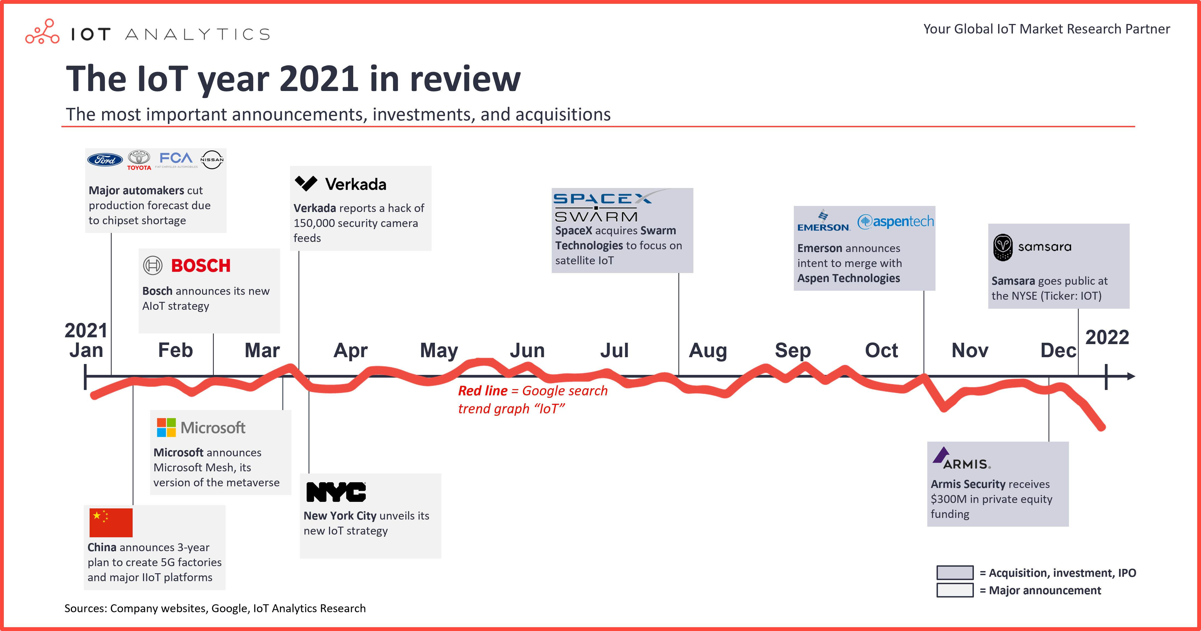

*Fig. 2.1*

**TECHNICAL DETAILS**

IoT-based home automation systems typically involve the use of a microcontroller, such as the ESP8266, to process data and control devices. Sensors are used to gather data and trigger actions, while actuators such as relays, motors and valves are used to control devices and appliances. Communication protocols, such as TCP/IP, Z-Wave, and Bluetooth Low Energy (BLE) are used to connect devices and transfer data. Cloud-based services are often used for remote monitoring and control, data storage and analysis. Mobile applications allow users to control and monitor their devices remotely. Power supply is also an important aspect to keep in mind while designing the system. Software development includes programming the microcontroller, setting up the communication protocols, and developing the mobile application.

<

**3.1 Description of the components used:**

We used the following components in our project:

1. **Microcontroller:** The ESP8266 microcontroller is a popular choice for IoT-based home automation systems due to its low cost, low power consumption, and built-in Wi-Fi capabilities. The microcontroller is responsible for processing data, controlling devices, and communicating with other devices and the cloud.
2. **Relay Module:** For AC devices like fan, lights etc., a relay module is used which will be connected to AC power supply and controlled by the app. A power relay module is an electrical switch that is operated by an electromagnet.
3. **Infrared Sensor:** An infrared sensor (IR sensor) is a radiation-sensitive optoelectronic component with a spectral sensitivity in the infrared wavelength range 780 nm - 50 µm. IR sensors are now widely used in motion detectors, which are used in building services to switch on lamps or in alarm systems to detect unwelcome guests.
4. **Gas Sensor:** Gas sensor converts the components and concentrations of various gases into standard electrical signals by using specific physicalandchemical effects. It has been widely used in the detection of noxious and harmful gases and natural gas leakage.
5. **Flame Sensor:** The flame sensor is a short, thin metallic rod that creates a small current of electricity to confirm the presence of a flame burning within the furnace. As the gas valve opens to kick-start the combustion process, the current moves from the sensor to detect the heat from a flame.
6. **Servo Motor:** Servo motors are great devices that can turn to a specified position. Usually, they have a servo arm that can turn 180 degrees. Using the Arduino, we can tell a servo to go to a specified position and it will go there.
7. **5V DC Motor & Motor Driver:** DC motors are rotary electrical machines that convert electrical energy into mechanical energy (Rotation). Motor drivers acts as an interface between the motors and the control circuits. Motor require high amount of current whereas the controller circuit works on low current signals.
8. **LEDs:** A light-emitting diode is a semiconductor device that emits light when current flows through it. Electrons in the semiconductor recombine with electron holes, releasing energy in the form of photons.
9. **Buzzer:** A buzzer or beeper is an audio signalling device, which may be mechanical, electromechanical, or piezoelectric (piezo for short).
10. **Breadboard:** A breadboard, solderless breadboard, or protoboard is a construction base used to build semi-permanent prototypes of electronic circuits.
11. **Jumper Wires:** A jumper wire is an electric wire that connects remote electric circuits used for printed circuit boards.

**3.2 Explanation of how the system works:**

An IoT-based home automation system works by connecting various devices and appliances in a home through a network of sensors, actuators, and a microcontroller. The system can be controlled and monitored remotely through a mobile application or a web interface.

Here is a general explanation of how the system works:

1. **Sensors:** Sensors such as temperature sensors, motion sensors, and light sensors are placed throughout the home to gather data and send it to the microcontroller. These sensors can be used to detect the presence of people in a room, changes in temperature, or the presence of flame in a room.
2. **Microcontroller:** The microcontroller, such as the ESP8266, receives the data from the sensors and processes it to determine the appropriate actions to take. The microcontroller can also be used to send data to the cloud-based services and receive commands from the mobile application.
3. **Actuators:** Actuators such as relays, motors, and valves are connected to the microcontroller and used to control devices and appliances in the home. For example, a relay can be used to turn on and off a light, or a motor can be used to open and close a window.
4. **Communication protocols:** The microcontroller uses communication protocols such as TCP/IP, Zigbee, and Bluetooth Low Energy (BLE) to connect to the other devices and transfer data.
5. **Cloud computing:** Cloud-based services are used to store and analyze data, as well as to provide remote access to the system. The data can be used to generate reports and insights, or to trigger automated actions.
6. **Mobile application:** A mobile application is provided to the user, allowing them to control and monitor the system remotely. The application can be used to set schedules, adjust settings, and receive notifications. In this project, we used Blynk mobile application through which we control the devices and monitor every change in any sensor.

In this way, the system can be used to automate tasks such as adjusting the thermostat, turning off appliances when not in use, and controlling lighting and entertainment systems. The system can also be used to monitor and improve the security of a home and optimize energy consumption.

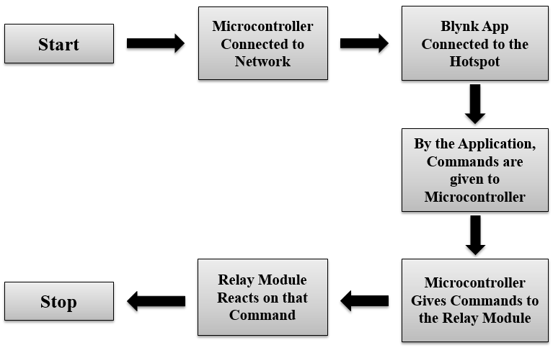

*Fig. 3.1*

**3.3 Discussion on the programming language:**

The ESP8266 microcontroller is commonly programmed using the Arduino programming language, which is based on C++. Arduino is an open-source electronics platform that allows developers to write code and upload it to the microcontroller. It provides a user-friendly development environment and a large community of developers who share code and libraries.

Additionally, there are other languages and frameworks that can be used to program the ESP8266, such as MicroPython, Lua, and NodeMCU. The mobile application for the system can be developed using various mobile app development frameworks such as React Native, Ionic, or Xamarin.

The cloud-based services can be developed using various web development frameworks such as Node.js, Django, or Ruby on Rails.

The choice of programming language and development framework will depend on the specific requirements of the project, the skill set of the development team, and the available resources.

**SYSTEM DESIGN AND IMPLEMENTAION**

The system design and implementation of an IoT-based home automation system can include the following steps:

1. **Requirements gathering:** The first step is to gather the requirements of the system. This includes identifying the specific tasks that the system should be able to perform, such as controlling the lighting, temperature, and appliances in the home.
2. **Hardware selection:** In the next step, we selected the hardware components that will be used in the system. This includes the microcontroller, sensors, actuators, and other components.
3. **Circuit design:** The next step is to design the circuit that connects all the components together. This includes connecting the sensors, actuators, and microcontroller and any other components to the power supply.
4. **Software development:** We linked the software which we used to run the system. This step also includes programming the microcontroller, setting up the communication protocols, and developing the mobile application.
5. **Cloud-based services:** Setting up the cloud-based services such as remote monitoring and control, data storage, and analysis.
6. **Testing and debugging:** Once the hardware and software are developed, we tested the system and debugged any issues that were found.
7. **Deployment:** After testing and debugging, the system is ready to be deployed in the home environment.
8. **Maintenance:** The system needs to be maintained and updated regularly to ensure that it is functioning properly and is secure.

The above steps are general and the specific design and implementation will depend on the requirements of the project and the skills of the development team. It's important to have a clear and detailed plan before starting the implementation, and to test and validate the system at every step to ensure that the final solution meets the requirements.

**4.1 Experimental Procedures:**

The testing procedures for an IoT-based home automation system will depend on the specific design and implementation of the project, but here are some general steps that may be involved in testing the system:

1. **Unit testing:** Each individual component of the system should be tested separately to ensure that they are working correctly. This includes testing the microcontroller, sensors, and actuators.
2. **Integration testing:** Once the individual components have been tested, the next step is to test how they work together. This includes testing the communication between the microcontroller and the sensors and actuators, as well as the communication between the microcontroller and the cloud-based services.
3. **Functional testing:** The system should be tested to ensure that it is able to perform the tasks it was designed to do. This includes testing the system's ability to control the devices and appliances in the home, as well as its ability to collect and analyze data.
4. **User acceptance testing:** The system should be tested by end-users to ensure that it is user-friendly and meets their needs.
5. **Performance testing:** The system should be tested under different conditions and scenarios to evaluate its performance. This includes testing the system's ability to handle a large number of devices and users, as well as its ability to handle different types of data.
6. **Security testing:** The system should be tested to ensure that it is secure and that it meets the security requirements. This includes testing the system's ability to handle different types of attacks, as well as its ability to protect data and user privacy.
7. **Stress testing:** The system should be tested to ensure that it can handle high loads and that it does not crash or malfunction under high stress.

It's important to have a clear and detailed plan before starting the testing procedures, and to test and validate the system at every step to ensure that the final solution meets the requirements.

**4.2 Description of the overall architecture:**

The overall architecture of an IoT-based home automation system using ESP8266 microcontroller, relay module, gas sensor, infrared sensor, flame sensor, servo motor, 5V DC motor, motor driver, LEDs, buzzer, breadboard and jumper wires can be described as follows:

1. **Microcontroller:** The ESP8266 microcontroller acts as the brain of the system, it receives input from various sensors, process the data and control the actuators.
2. **Relay Module:** The relay module is used to control the home appliances, such as lights and fans, by switching them on or off.
3. **Gas Sensor:** The gas sensor is used to detect the presence of gases such as methane, propane, and carbon monoxide.
4. **Infrared Sensor:** The infrared sensor is used to detect the presence of human or object, it can be used for security or automation purposes
5. **Flame Sensor:** The flame sensor is used to detect fire, it can be used for security or automation purposes
6. **Servo Motor:** The servo motor is used to control the movement of various devices, such as curtains, blinds and other devices
7. **5V DC Motor:** The 5V DC motor is used to control the movement of various devices such as fans, pump and other devices
8. **Motor Driver:** The motor driver is used to control the speed and direction of the 5V DC motor
9. **LEDs:** LEDs are used as visual indicators to show the status of the system
10. **Buzzer:** The buzzer is used as an audible indicator to alert the user when an event occurs
11. **Breadboard and Jumper Wires:** The breadboard and jumper wires are used to connect the components of the system together.

All these components are connected on the breadboard and controlled by the ESP8266 microcontroller, the system can also be connected to internet and controlled remotely by using cloud-based services and mobile application. This system can be used to control and monitor the home appliances, detect gases and fire, detect the presence of human or objects, and provide security and automation features.

**4.3 Circuit diagram:**

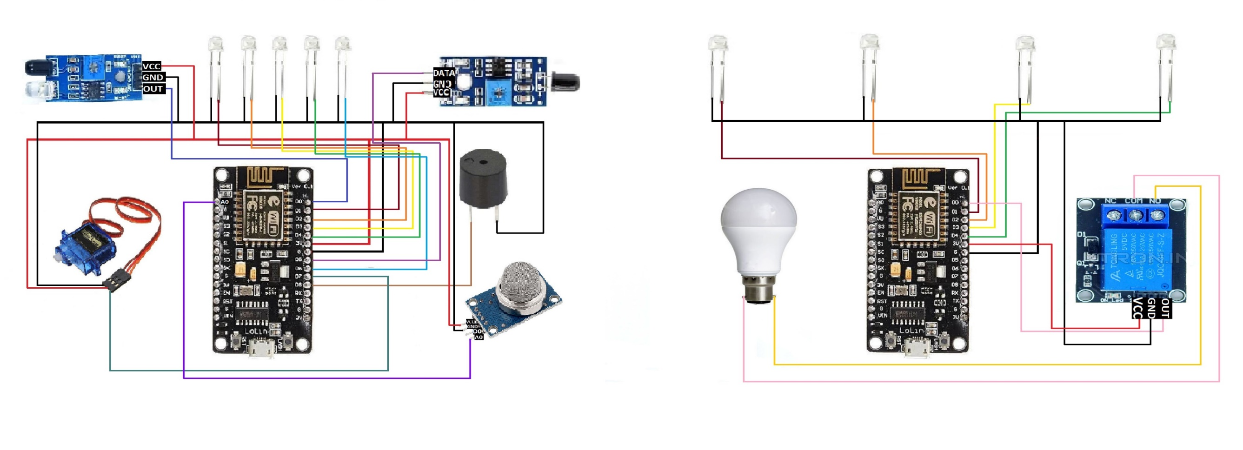

*Fig. 4.1*

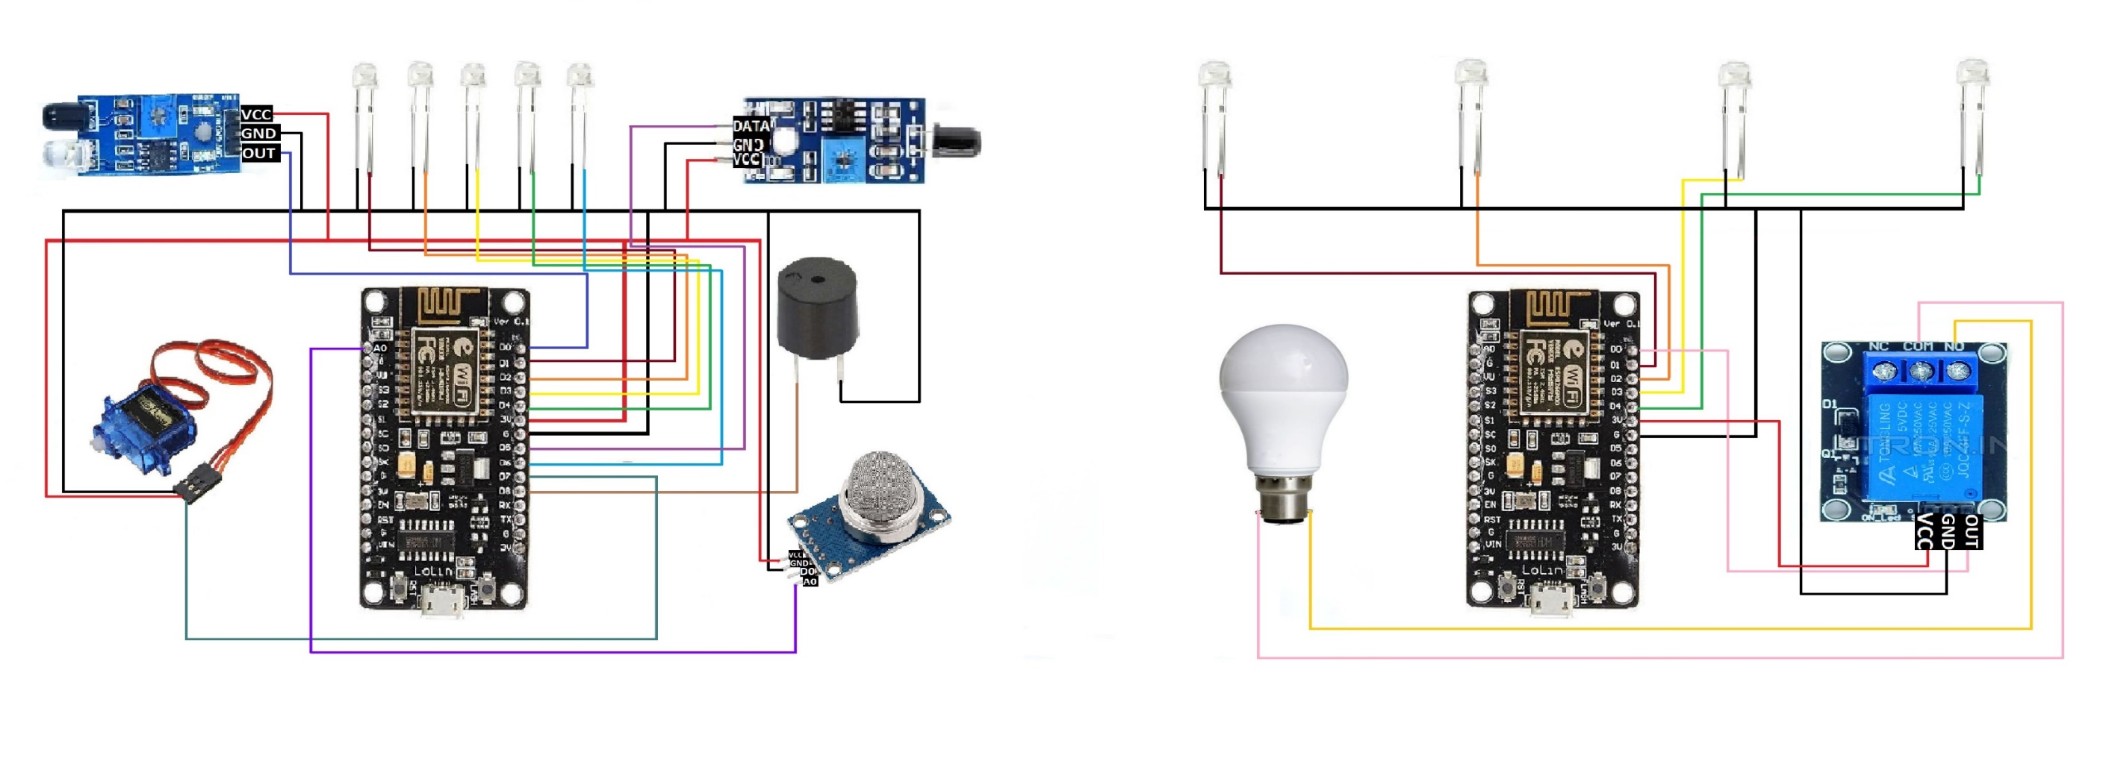

*Fig. 4.2*

**RESULT AND ANALYSIS**

After demonstrating many times, we achieved the succes and got the result which we would like to show with some images:

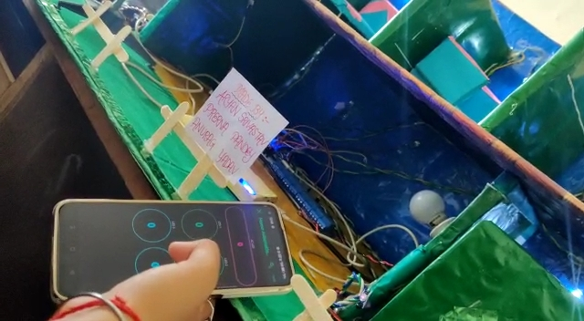

*Fig. 5.1*

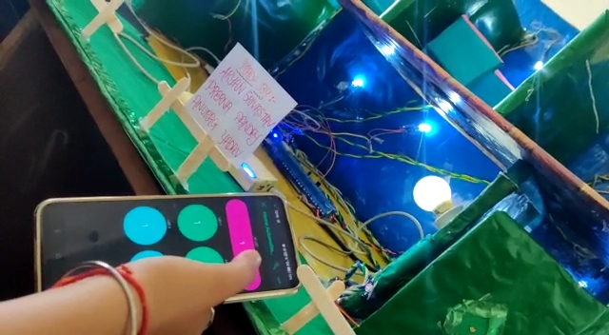

*Fig. 5.2*

* 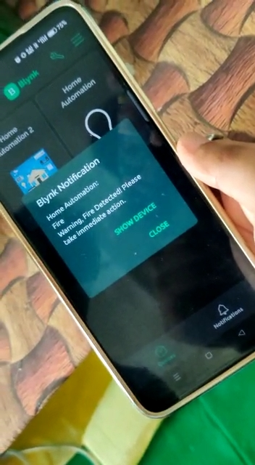*

*Fig. 5.3 Fig. 5.4*

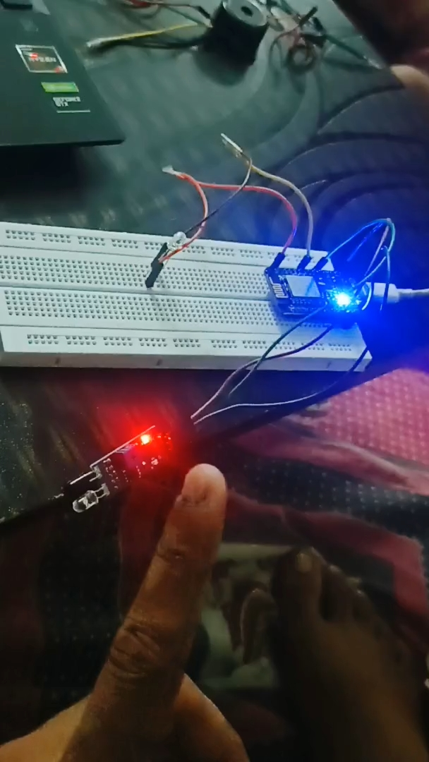 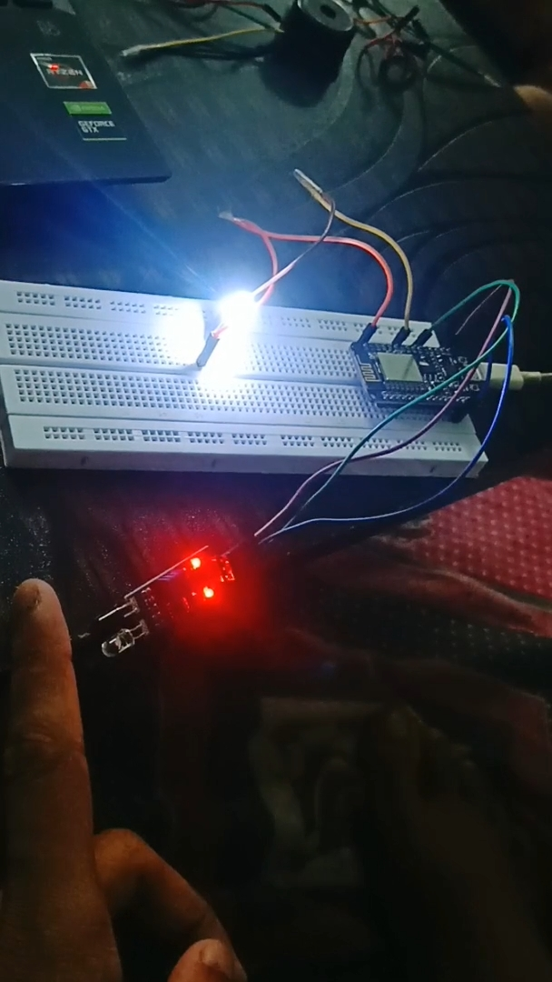

*Fig. 5.5 Fig. 5.6*

It’s importatnt to note that these images are just a part of the whole system. There are many more functions which can be done in our model.

**5.1 Explanation of the result:**

The results of an IoT-based home automation system refer to the outcome or outcome of the system's performance. The results can be divided into two categories: quantitative and qualitative results.

* Quantitative results are numerical data that can be measured and analyzed. For example, the gas sensor which measures the amount of gas present in the room, the number of times it is operated and the time it was operated.
* Qualitative results are descriptive data that cannot be measured numerically, but can be observed and reported. For example, flame and infrared sensors can detect heat and infrared signature and report to the connected devices, they can provide a level of security which create a safe and secure environment.

The results of the system can be analyzed and compared against the goals and objectives set for the system. It can be used to identify areas for improvement, optimization, and to measure the system's performance.

For example, if the goal of the system is to reduce energy consumption, the results can be analyzed to see if the energy consumption of each device has decreased. If the goal is to improve the level of security, the results can be analyzed to see if the system is able to detect and alert the user of potential security and safety hazards.

Overall, the explanation of the results of an IoT-based home automation system refers to the assessment of the system's performance against the goals and objectives set for the system, and the analysis of the data collected from the system to identify areas for improvement and optimization.

**5.2 Discussion of benefits achieved by the system**

An IoT-based home automation system can offer several benefits, such as:

1. **Energy savings:** The system can be used to monitor and control energy usage of home appliances and devices, leading to a reduction in energy consumption and cost savings.
2. **Improved safety:** The system can be used to detect and alert the user of potential security and safety hazards, such as gas leaks or fires.
3. **Increased comfort:** The system can be used to control the temperature, lighting, and other environmental factors in the home, leading to increased comfort for the users.
4. **Increased convenience:** The system can be controlled remotely through a mobile application, allowing the user to control the devices and appliances in the home from anywhere.
5. **Remote monitoring:** The system can be used to monitor the status of the home and its appliances remotely, which can be useful for people who are away from home for long periods of time.
6. **Automation:** The system can be used to automate certain tasks such as switching on/off lights, fans or turning on the AC when the temperature exceeds a certain limit.
7. **Analysis:** The system can be used to collect and analyze data about the usage patterns of home appliances and devices, which can be used to identify areas for improvement and optimization.
8. **Flexibility:** The system allows the user to configure and customize the settings according to their needs and preferences, which provides them with more control over their home environment.
9. **Scalability:** The system can be easily expanded by adding new devices and sensors, which allows the user to expand the functionality and capabilities of the system over time.
10. **Cost-effective:** The system can be implemented at a lower cost compared to traditional home automation systems, which makes it more accessible to a larger audience.

Overall, an IoT-based home automation system can provide many benefits, including energy savings, improved safety, increased comfort, and increased convenience.

**5.3 Analysis of any security concern:**

IoT devices were not built with security in mind. This results in myriad IoT security challenges that can lead to disastrous situations. Unlike other technology solutions, few standards and rules are in place to direct IoT security. In addition, most people do not understand the inherent risks with IoT systems. Nor do they have any idea about the depth of IoT security challenges. Among the many IoT security issues are the following:

1. **Lack of visibility:** Users often deploy IoT devices without the knowledge of IT departments, which makes it impossible to have an accurate inventory of what needs to be protected and monitored.
2. **Limited security integration:** Because of the variety and scale of IoT devices, integrating them into security systems ranges from challenging to impossible.
3. **Open-source code vulnerabilities:** Firmware developed for IoT devices often includes open-source software, which is prone to bugs and vulnerabilities.

**5.4 Points for the resolution of security concerns:**

It's important to address these security concerns by implementing appropriate security measures such as:

1. Using strong and unique passwords for all devices and the system.
2. Encrypting the communication between devices and the system.
3. Regularly updating the firmware of all devices.
4. Using firewalls and intrusion detection systems.
5. Monitoring the system for unusual activity.
6. Conducting regular security audits.
7. **Prioritize Wi-Fi and private network.**
8. **Monitor baseline network and device behaviour.**
9. **Take into consideration the**[different protocols](https://www.trendmicro.com/vinfo/us/security/news/internet-of-things/lost-in-translation-when-industrial-protocol-translation-goes-wrong)**used by IoT devices.**

By addressing these security concerns, the system can be made more secure and protect the privacy of the users.

**SUMMARY AND CONCLUSION**

**6.1 Summary:**

In summary, home automation systems have become increasingly popular in recent years due to their ability to provide remote control and monitoring of home appliances and devices. These systems use microcontrollers, sensors, and other electrical components to collect data from the environment, process the data and control the home appliances. The system can be connected to the internet and controlled remotely using a mobile application or web interface.

The benefits of using an IoT-based home automation system include energy savings, improved safety, increased comfort, and increased convenience. The system can also be used to automate certain tasks such as switching on/off lights, fans or turning on the AC when the temperature exceeds a certain limit. The system can also be used to monitor the usage patterns of home appliances and devices to identify areas for improvement and optimization.

However, these systems also pose security concerns, such as unauthorized access, data breaches, device spoofing, and man-in-the-middle attacks. Therefore, it is important to implement appropriate security measures such as using strong and unique passwords, encrypting the communication between devices and the system, regularly updating the firmware of all devices, and conducting regular security audits to protect the privacy of users and secure the system.

**6.2 Conclusion:**

An automation system is a technology that allows the user to control and monitor home appliances and devices remotely through a mobile application or web interface. This system can provide many benefits such as energy savings, improved safety, increased comfort, and increased convenience. The system is built using components such as ESP8266 microcontroller, relay module, gas sensor, infrared sensor, flame sensor, servo motor, 5V DC motor, motor driver, LEDs, buzzer, breadboard, and jumper wires. The system can be connected to internet and controlled remotely.

The results of an IoT-based home automation system are analyzed against the goals and objectives set for the system. This analysis is used to identify areas for improvement and optimization.

In conclusion, an IoT-based home automation system can provide many benefits, but also poses some security concerns. By implementing appropriate security measures and regularly monitoring the system, these concerns can be mitigated to provide a secure and efficient home automation system.

**5.3 Scope for future research:**

The scope for future research on IoT-based home automation systems can include the following:

1. **Improved security:** Developing new and more secure methods to protect the system from unauthorized access and data breaches.
2. **Energy management:** Investigating and developing new techniques to optimize energy consumption in the home.
3. **Human-computer interaction:** Investigating ways to improve the user experience, such as developing more intuitive interfaces or natural language processing capabilities.
4. **Smart grid integration:** Integrating the system with smart grid technology to allow for real-time monitoring and control of energy usage.
5. **Machine learning and artificial intelligence:** Incorporating machine learning and AI algorithms to improve the system's performance, such as optimizing energy usage or detecting potential security threats.
6. **Voice control:** Investigating the use of voice control to interact with the system, which can improve the user experience and accessibility.
7. **Smart home integration:** Investigating the integration of multiple smart home devices and services to provide a more comprehensive solution to home automation.
8. **Internet of things Security:** Investigating ways to improve the security of IoT devices and systems, especially in the context of home automation.
9. **Edge computing:** Investigating the use of edge computing to process data locally, which can improve the performance and reduce the latency of the system.

Overall, there are many opportunities for future research on IoT-based home automation systems, including developing new and more secure methods, optimizing energy consumption, and improving the user experience.

**6.4 References:**

[1] Internet of Things (IOT): Research Challenges and Future Applications AbdelRahman H. Hussein Department of Networks and Information Security Faculty of Information Technology / Al-Ahliyya Amman University, (IJACSA) International Journal of Advanced Computer Science and Applications, Vol. 10, No. 6, 2019.

[2] Zhou J, Cap Z, Dong X, Vasilakos AV. Security and privacy for cloud-based IoT: challenges. IEEE Commun Mag. 2017;55(1):26–33. <https://doi.org/10.1109/MCOM.2017.1600363CM>.

[3] Sfar AR, Natalizio E, Challal Y, Chtourou Z. A roadmap for security challenges in the internet of things. Digit Commun Netw. 2018;4(1):118–37.

[4] Minoli D, Sohraby K, Kouns J. IoT security (IoTSec) considerations, requirements, and architectures. In: Proc. 14th IEEE annual consumer communications & networking conference (CCNC), Las Vegas, NV, USA, 8–11 January 2017. <https://doi.org/10.1109/ccnc.2017.7983271>.

[5] Internet of Things is a revolutionary approach for future technology enhancement: a review Sachin Kumar, Prayag Tiwari and Mikhail Zymbler, Kumar et al. J Big Data (2019) 6:111 <https://doi.org/10.1186/s40537-019-0268-2>.

[6] Review of Internet of Things (IoT) for Future Generation Wireless Communications Dr.Nookala Venu, Dr.A.ArunKumar , Karthik Kumar Vaigandla, International Journal for Modern Trends in Science and Technology, 8(03): 01-08, 2022 Copyright © 2022 International Journal for Modern Trends in Science and Technology ISSN: 2455-3778 online DOI: <https://doi.org/10.46501/IJMTST0803001>.

[7] R. Jain, “A Congestion Control System Based on VANET for Small Length Roads”, Annals of Emerging Technologies in Computing (AETiC), vol. 2, no. 1, pp. 17–21, 2018, DOI: 10.33166/AETiC.2018.01.003.

[8] S. Soomro, M. H. Miraz, A. Prasanth, M. Abdullah, “Artificial Intelligence Enabled IoT: Traffic Congestion Reduction in Smart Cities,” IET 2018 Smart Cities Symposium, pp. 81–86, 2018, DOI: 10.1049/cp.2018.1381.

[9] Internet of Things for Smart Cities Andrea Zanella, Senior Member, IEEE, Nicola Bui, Angelo Castellani, Lorenzo Vangelista, Senior Member, IEEE, and Michele Zorzi, Fellow, IEEE, IEEE INTERNET OF THINGS JOURNAL, VOL. 1, NO. 1, FEBRUARY 2014.

[10] Number of IoT active connections in EU statistics -

<https://www.google.com/url?sa=i&url=https%3A%2F%2Fwww.statista.com%2Fstatistics%2F691862%2Ftracking-iot-active-connections-in-the-eu%2F&psig=AOvVaw2Y7KKRS8wAdUrwnk0u9jQ1&ust=1668926919412000&source=images&cd=vfe&ved=0CBAQjRxqFwoTCLi9g-HTufsCFQAAAAAdAAAAABAE>

[11] Fafoutis X, et al. A residential maintenance-free long-term activity monitoring system for healthcare applications. EURASIP J Wireless Commun Netw. 2016. <https://doi.org/10.1186/s13638-016-0534-3>.

[12] V. Sundareswaran and M. S. null, “Survey on Smart Agriculture Using IoT,” International Journal of Innovative Research in Engineering & Management (IJIREM), vol. 5, no. 2, pp. 62–66, 2018.

[13] Sebastian S, Ray PP. Development of IoT invasive architecture for complying with health of home. In: Proc: I3CS, Shillong; 2015. p. 79–83.

[14] Internet of Things research study: Hewlett Packard Enterprise Report. 2015.

<http://www8.hp.com/us/en/hp-news/press-release.html%3fid%3d1909050#.WPoNH6KxWUk>

[15] Van-der-Veer H, Wiles A. Achieving technical, interoperability-the ETSI approach, ETSI White Paper No. 3. 2008.

<http://www.etsi.org/images/files/ETSIWhitePapers/IOP%20whitepaper%20Edition%203%20final.pdf>

# [16] IoT 2021 in review: The 10 Most Relevant IoT Developments of the Year

# <https://iot-analytics.com/iot-2021-in-review/>